
Name: Muhammad Zain
CU-4353-2023
BSSE-2023-C
Last Task 4

Marks Above 50 & Odd Number Program:
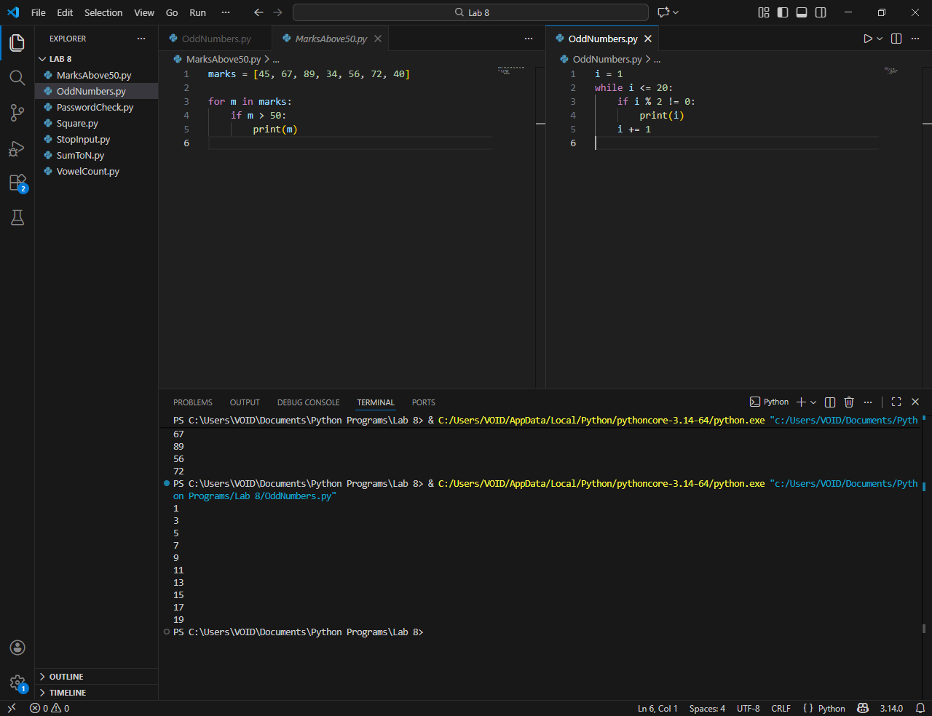

Password Check & Square Program:
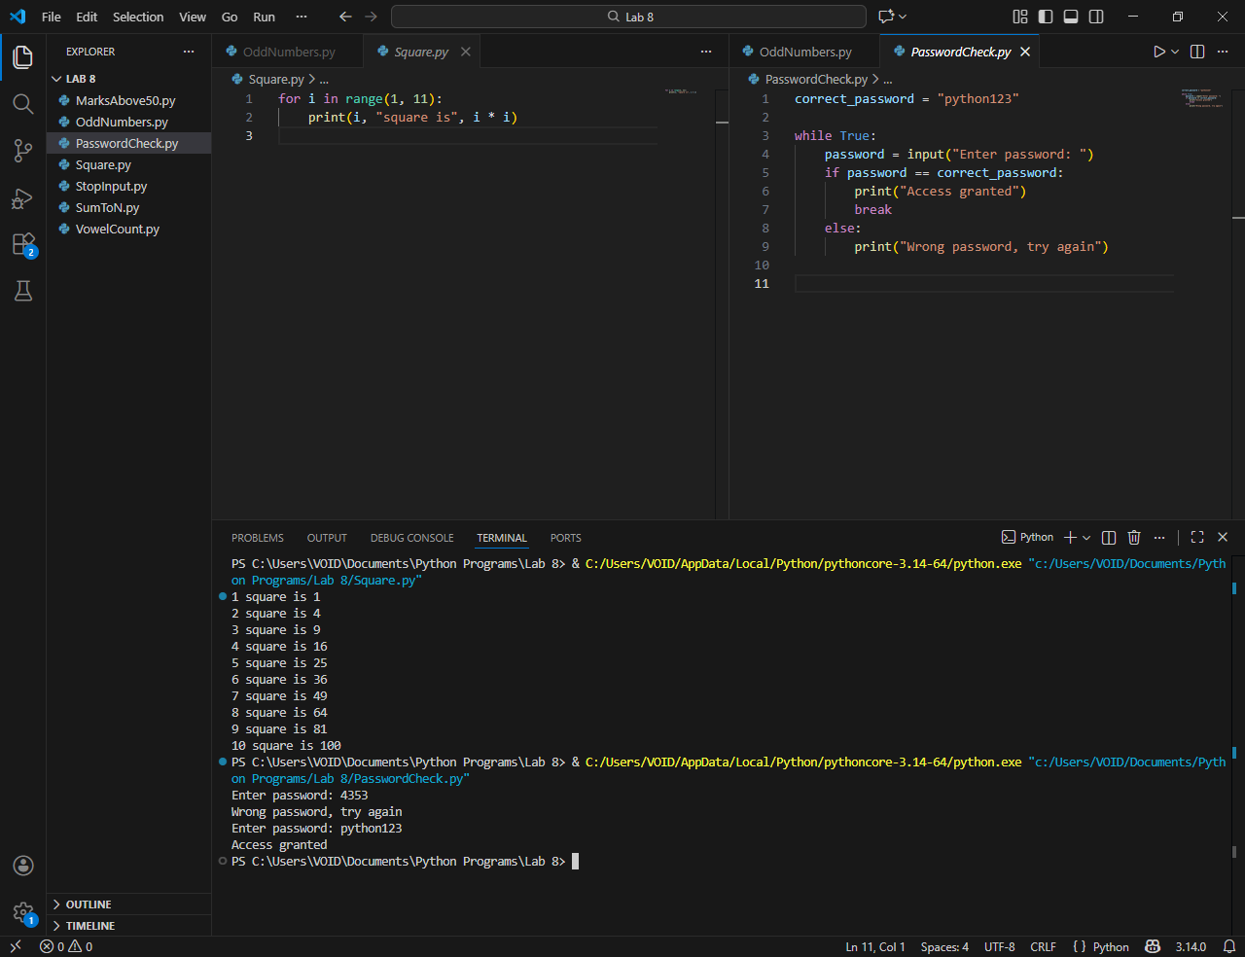

Stop input & Sum to N Program:
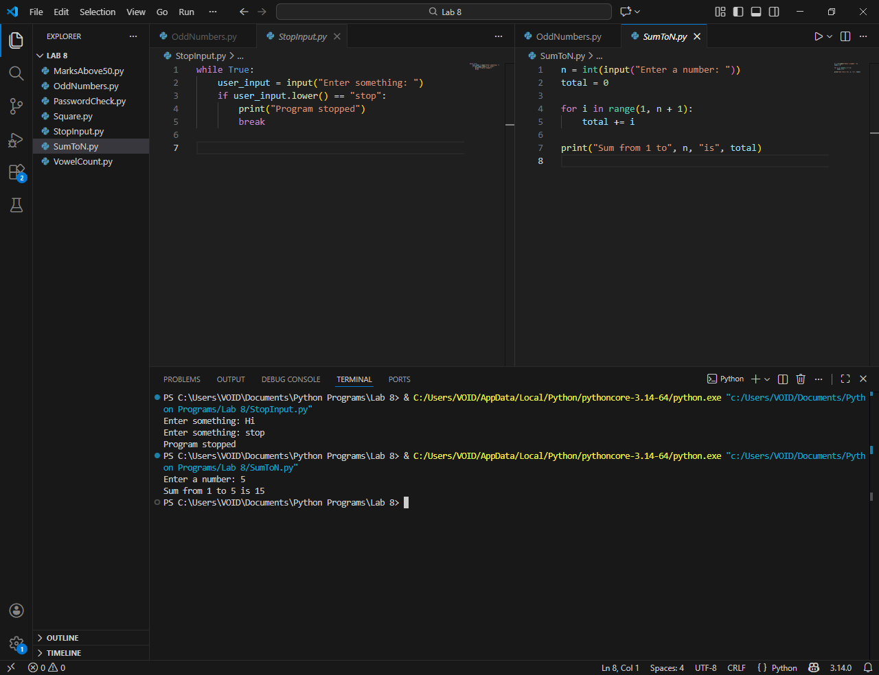

Vowel Count Program:
